Crossy Road Analysis

Based on the reading and research I have undertaken; in this essay, I am going to concentrate on the following game Crossy Road. I will be analyzing how the games mechanics drive revenue and how developers have marketed their game. Inspired by 'Flappy bird, Temple run and frogger' Crossy road is an arcade game made for 'Android, iOS and windows phone', created by the Australian developers named Hipster Whale.

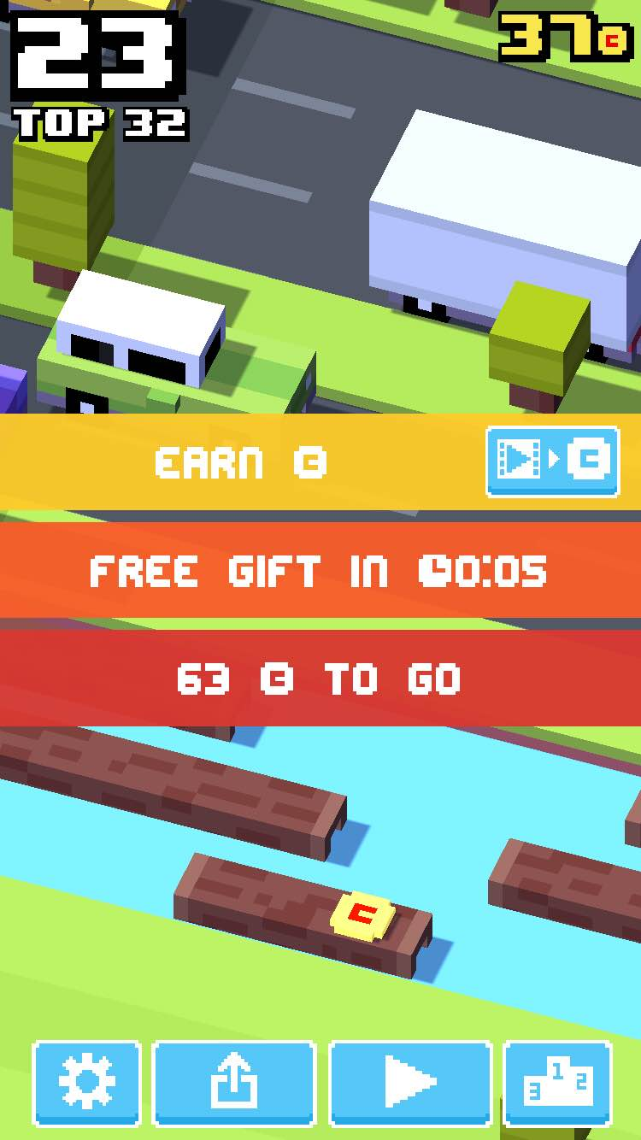Mechanics

One mechanic that drives revenue in Crossy road is their time mechanic. The timer is displayed once the player has died, it is used to persuade the player to return to the game after a set amount of time. If they do return they receive a free gift (Example: 110c). Time is also used to set goals for the player to achieve. Having Read the article ***'Crossy road: 7 kinds of persuasive design techniques in a tiny package’*** it says;

*"Seconds: get as far as you can in one game. Minutes: collect enough coins to buy another avatar. Hours: beat your personal best*. *Days: beat your friends via game center leaderboard. Weeks: collect all the avatars"*

This shows that the players can accomplish their goals at any time of the day, then they are rewarded for playing continuously. The goals create retention, it keeps the players returning as they always have a chance to beat their high score or collect as many coins in one game session. While the player is away using another app or generally off their phone, Crossy road sends push notifications to remind the player they have a set amount of time left until they win a free prize. In the same article, it says *"Knowing you'll get another gift in a few hours creates a sort of "appointment dynamic".* Which suggests once the player has received the message there is a higher chance they will return to the game.

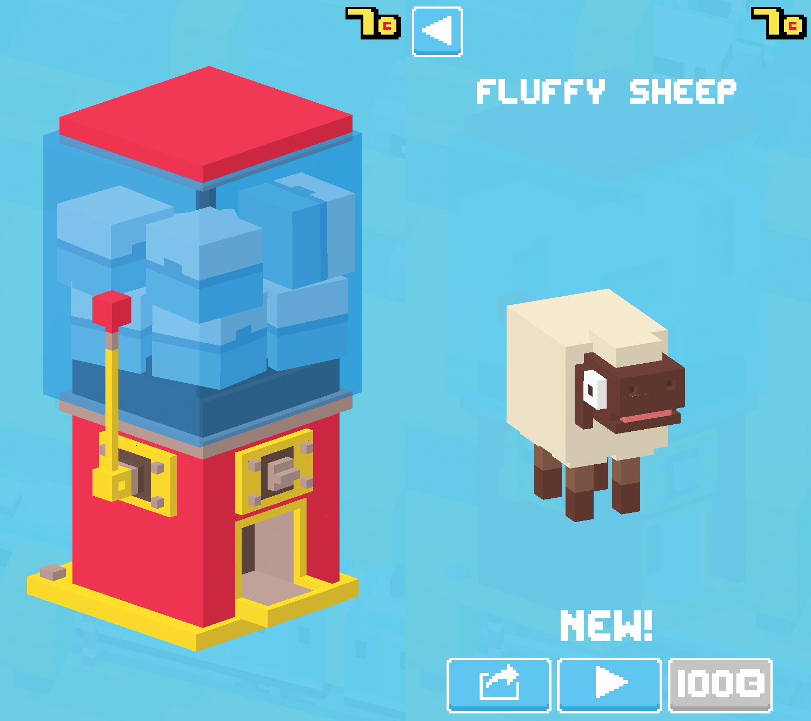Another mechanic that drives revenue is their random reward system. Once the player has received their free gift of 110c or have collected the coins manually, they can then pull the lever on the machine. The machine requires 100c to reward the player with a random new mascot. The random reward system acts as a variable reward, the players become intrigued to see which mascot they will be rewarded with next, making the player want to collect more coins to return to the machine. While reading ***Hooked: How to build habit-forming products*** it says “*what draws us to act is not sensation we receive from the reward itself, but the need to alleviate the craving for that reward.”* This implies that upon being rewarded once, it sends out an emotion to the brain realizing you can get a new mascot at an easy and good steady pace, this making the player want new mascots.

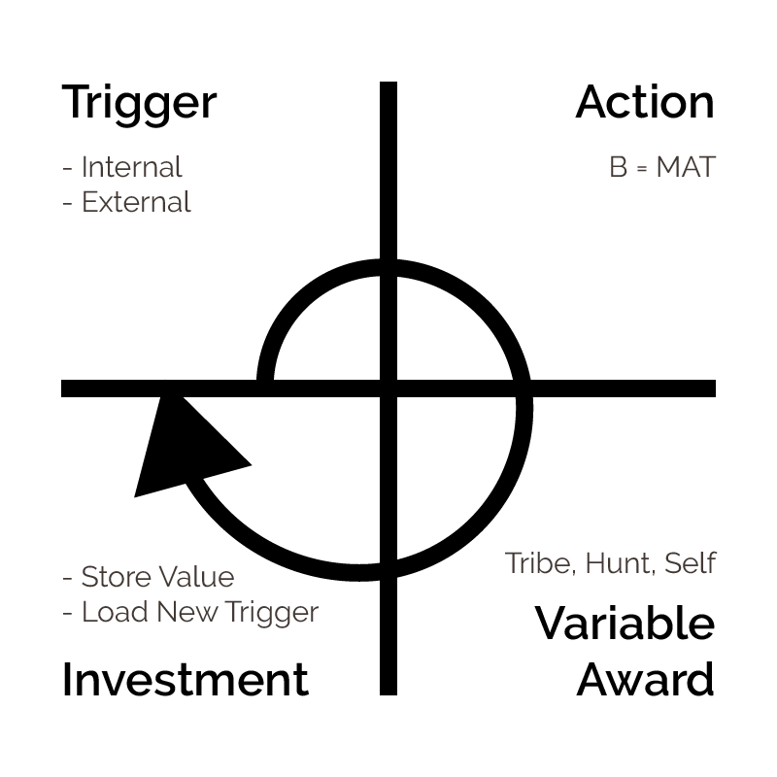Marketing

While reading ***Hooked: How to build habit-forming products*** it introduced the hook model, Hipster whale used the hook model in Crossy Road. The start of the model introduces *triggers*. Once the players turn has ended, there will occasionally be a share button which would send their high score to a source of social media e.g. *Facebook, Twitter* etc. Once the public view their friends high score it will trigger them to play so they can beat it. The second part of the model introduces *Action.* Crossy Road can be accessed by clicking on the ‘*play now’* button which lets you download the game and start playing. On the ***Google play store,***it says ‘*Updated 30th November 2016- Installs 50,000,000 - 100,000,000’.*

The third part of the hooked model introduced *Variable rewards*. The consistency of coins collected and spent in the machine to collect a random new mascot creates a variable reward. Once the player sees that they can unlock an item and make a collection of mascots it keeps the players intrigued. In ***Hooked: How to build habit-forming products*** it says; “*introducing variability multiplies the effect, creating a focused state, which suppresses the areas of the brain associated with judgment and reason while activating the parts associated with wanting and desire”.*

The final part of the hook model is *Investment. As* Crossy road is a free to play game, the developers decided to use pop up advertisement regularly to gain investment. The players are persuaded to watch a short twenty second clip if they see they will gain 20c (twenty credits). While reading ***Why Crossy Road focused on sharing & retention, not UA & monetization*** it says " Crossy Road, made over $6 million on integrated video ads in its first 90 days ".

As well as this Crossy road uses their mascots to make an investment. On the previous ***Google Play Store,*** it says *“In-app Products -£0.58 - £3.49 per item”.* Having played Crossy road, purchasing mascots and collecting mascots makes the player want to create their own collection, therefore they will pay the minimum of *“£0.58”* to add to it. Mascots that are “*£.3.49”* can only be purchased, they cannot be collected via the machine as some have their own perk. On the **Fandom page powered by wikia** it says the piggy bank “*would give you 40c instead of 20c”* This would persuade a player to buy the mascot as they get rewarded with double coins.

Conclusion

Overall, I conclude that the main mechanics that helps drive revenue is their timer and random rewards. The timer was effective as it persuades the player to return to the game, this is important in any game design because it creates addictive behavior. As well as this, the random rewards creates addictive behavior when collecting free rewards, this is also important in game design to reward the player continuously. The hooked model is related to crossy road as they used trigger, action, investment and variable rewards, these drive revenue as it creates a cycle for the player to abide to, (see a high score, play the game, collect free gifts, and pay for new mascots).

Word count: 998

References

Crossy Road Timer. 2015. Web. 21 Nov. 2016.

<http://mobiledevmemo.com/wp-content/uploads/2015/04/crossy_road_watch_video_ad.jpg>

Crossy Road. Google play. N.p., 2016. Web. 21 Nov. 2016.

“Installs 50,000,000- 100,000,000”

“In-app Products -£0.58 - £3.49 per item”.

<https://play.google.com/store/apps/details?id=com.yodo1.crossyroad&hl=en_GB>

Hooked Model. 2016. Web. 3 Dec. 2016

<https://2.bp.blogspot.com/-PRejNzM6_cU/VtbR89wuh1I/AAAAAAAA9rM/ynqV8I6LhnQ/s1600/hook%2Bmodel-01.png>

Blogspot.com,. The Machine. 2016. Web. 3 Dec. 2016.

<http://3.bp.blogspot.com/-HLtlrrcNTms/VKE2B8Sd9oI/AAAAAAAAABc/QfVTGI0BeWU/s1600/Fluffy-Sheep.png>

Piggy Bank Wikia.com. N.p., 2015. Web. 3 Dec. 2016.

“Would give you 40c instead of 20c”

<http://crossyroad.wikia.com/wiki/Piggy_Bank>

Eyal, Nir. Hooked Eyal Hooked: How To Build Habit-Forming Products. 1st ed. Nir Eyal, Ryan Hoover, 2013.

Hooked Model

“Introducing variability multiplies the effect, creating a focused state, which suppresses the areas of the brain associated with judgment and reason while activating the parts associated with wanting and desire”

“What draws us to act is not sensation we receive from the reward itself, but the need to alleviate the craving for that reward.”

Why Crossy Road focused on sharing & retention, not UA & monetization. Web. 3 Dec. 2016.

“Crossy Road, made over $6 million on integrated video ads in its first 90 days ".

<https://www.chartboost.com/blog/2015/06/crossyroad-focused-on-sharing-retention/>

Crossy Road: 7 Kinds Of Persuasive Design Techniques In A Tiny Package | Design Thinking, User Experience Design, And Usability In South Africa - Deloitte Digital Design". Userexperience.co.za. Web. 3 Dec. 2016.

"Seconds: get as far as you can in one game. Minutes: collect enough coins to buy another avatar. Hours: beat your personal best. Days: beat your friends via game center leaderboard. Weeks: collect all the avatars"

"Knowing you'll get another gift in a few hours creates a sort of "appointment dynamic".

<http://www.userexperience.co.za/crossy-road-7-kinds-of-persuasive-design-techniques-in-a-tiny-package/>